**Step 1 of 3**



**Build a Dashboard Application with Plotly Dash**

In this lab, you will be building a Plotly Dash application for users to perform interactive visual analytics on SpaceX launch data in real-time.

This dashboard application contains input components such as a dropdown list and a range slider to interact with a pie chart and a scatter point chart. You will be guided to build this dashboard application via the following tasks:

* TASK 1: Add a Launch Site Drop-down Input Component
* TASK 2: Add a callback function to render success-pie-chart based on selected site dropdown
* TASK 3: Add a Range Slider to Select Payload
* TASK 4: Add a callback function to render the success-payload-scatter-chart scatter plot

***Note:Please take screenshots of the Dashboard and save them. Further upload your notebook to github.***

***The github url and the screenshots are later required in the presentation slides.***

Your completed dashboard application should look like the following screenshot:

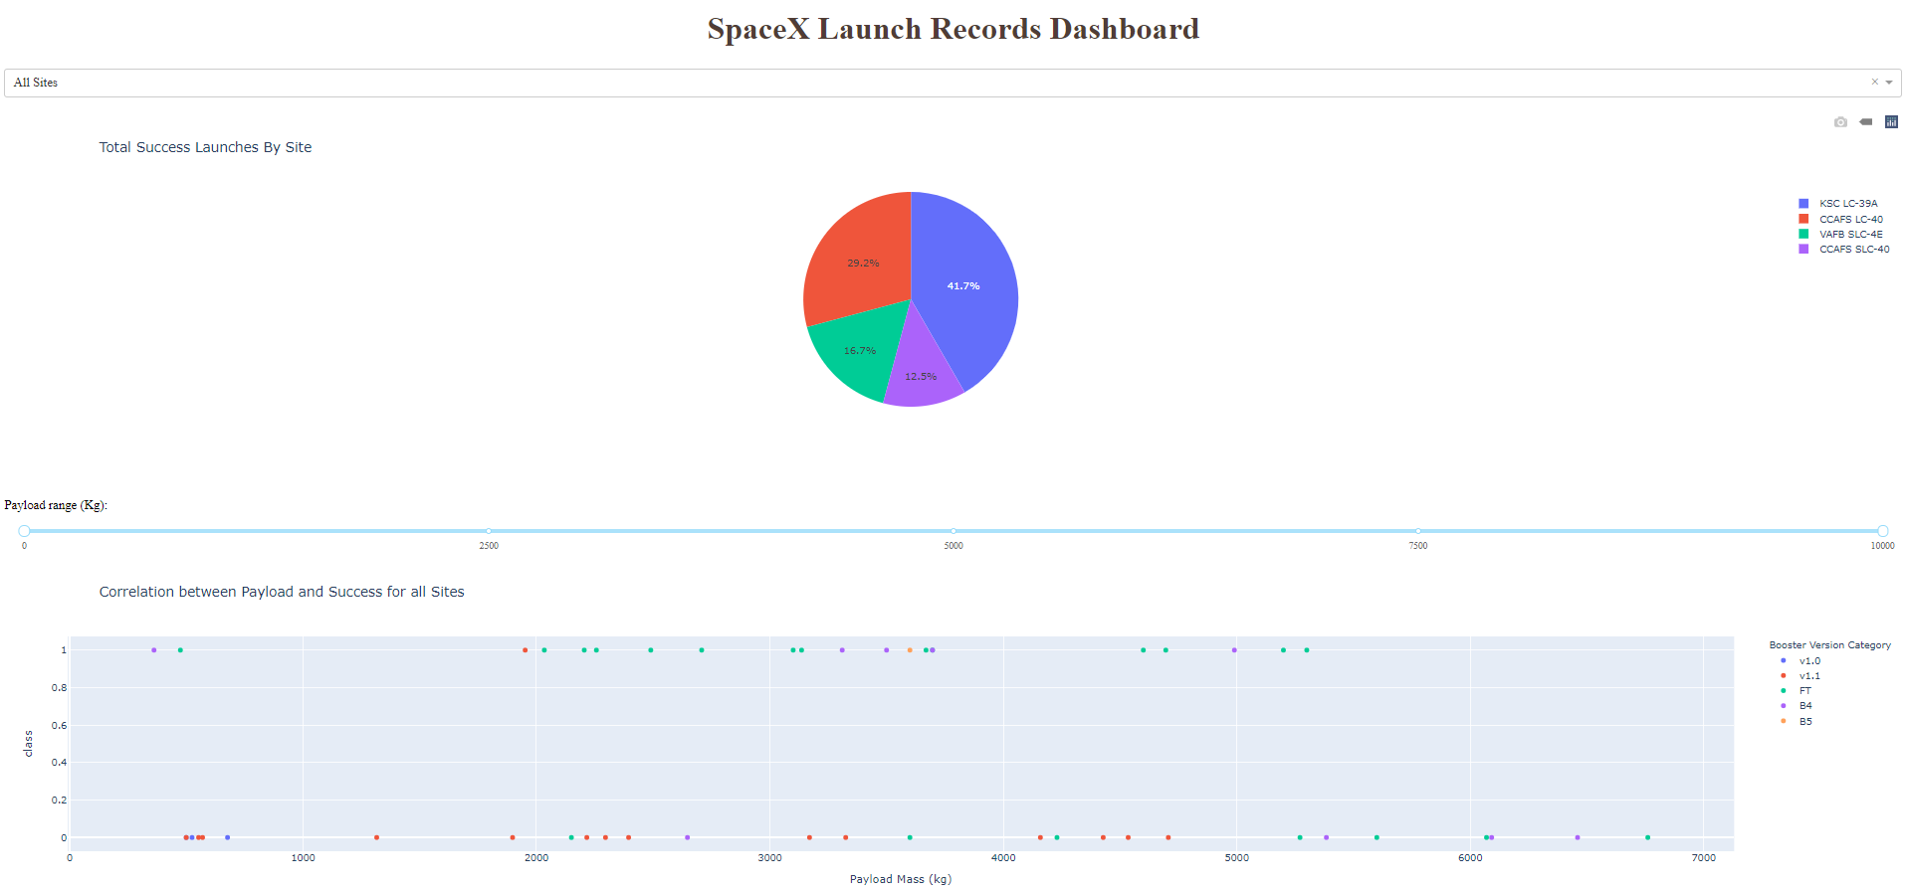

After visual analysis using the dashboard, you should be able to obtain some insights to answer the following five questions:

1. Which site has the largest successful launches?
2. Which site has the highest launch success rate?
3. Which payload range(s) has the highest launch success rate?
4. Which payload range(s) has the lowest launch success rate?
5. Which F9 Booster version (v1.0, v1.1, FT, B4, B5, etc.) has the highest

launch success rate?

**Estimated time needed:** 90 minutes

**Important Notice about this lab environment**

Please be aware that sessions for this lab environment are not persisted. When you launch the Cloud IDE, you are presented with a 'dedicated computer on the cloud' exclusively for you. This is available to you as long as you are actively working on the labs. Once you close your session or it is timed out due to inactivity, you are logged off, and this dedicated computer on the cloud is deleted along with any files you may have created, downloaded or installed.

The next time you launch this lab, a new environment is created for you. If you finish only part of the lab and return later, you may have to start from the beginning. So, it is a good idea to plan your time accordingly and finish your labs in a single session.

**Setup development environment**

**Install required Python packages**

* Open a new terminal, by clicking on the menu bar and selecting **Terminal**->**New Terminal**, as in the image below.

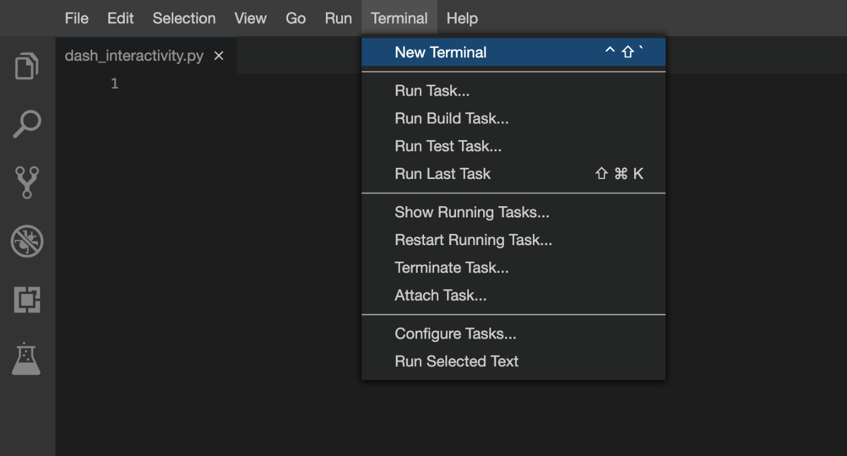

* Now, you have script and terminal ready to start the lab.

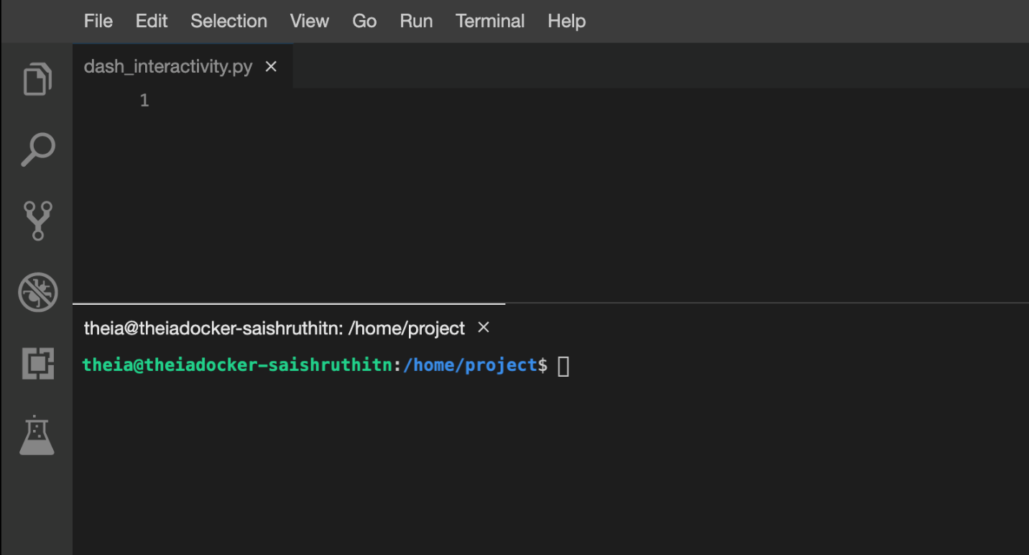

* Install python packages required to run the application.

Copy and paste the below command to the terminal.

**pip3** install pandas dash

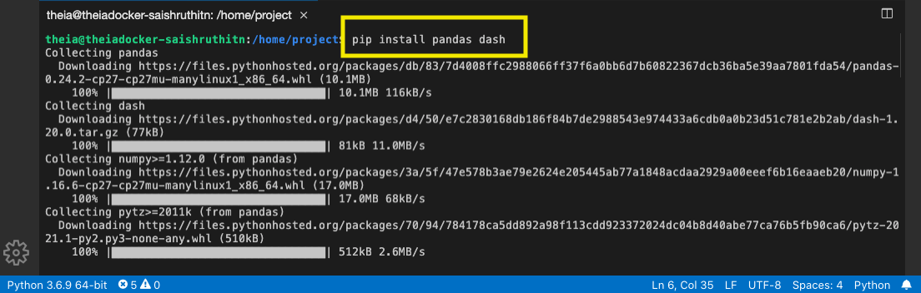

**Download a skeleton dashboard application and dataset**

First, let's get the SpaceX Launch dataset for this lab:

* Run the following wget command line in the terminal to download dataset as spacex_launch_dash.csv

**wget** "https://cf-courses-data.s3.us.cloud-object-storage.appdomain.cloud/IBM-DS0321EN-SkillsNetwork/datasets/spacex_launch_dash.csv"

* Download a skeleton Dash app to be completed in this lab:

**wget** "https://cf-courses-data.s3.us.cloud-object-storage.appdomain.cloud/IBM-DS0321EN-SkillsNetwork/labs/module_3/spacex_dash_app.py"

* Test the skeleton app by running the following command in the terminal:

**python3** **spacex_dash_app**.py

* Observe the port number (8050) shown in the terminal.

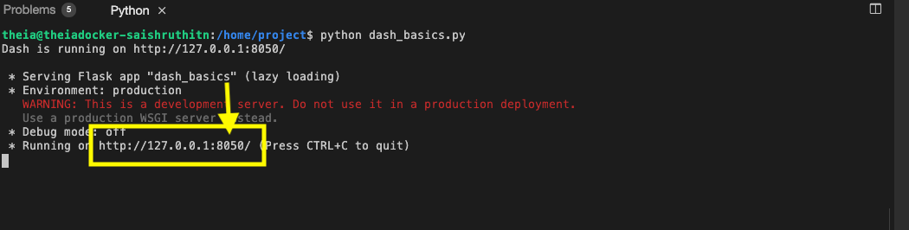

* In the left Navigation Pane click on Others and click Launch Application option under it.Enter the application port number as 8050. Click Your Application.

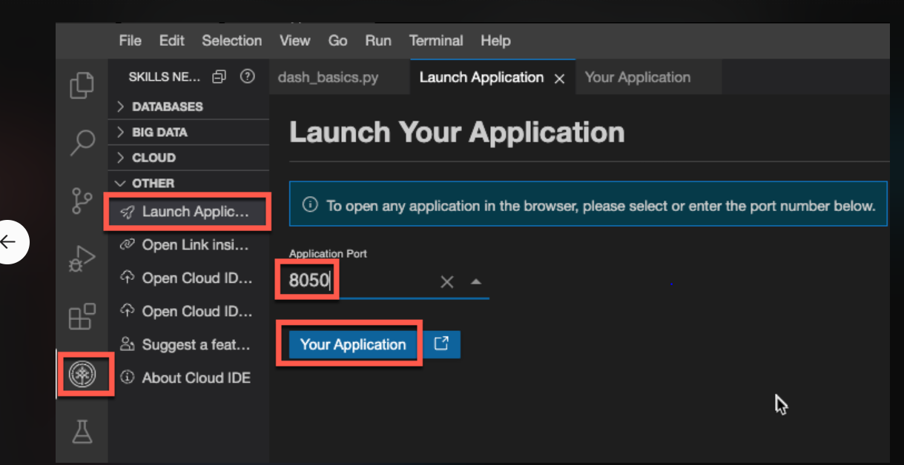

* You should see a nearly blank web page indicating a successfully running dash app.

Next, let's fill the skeleton app with required input/output components and callback functions.

If you need to refresh your memory about Plotly Dash components and callback functions, you may refer to the lab you have learned before:

[**Plotly Dash Lab**](https://cf-courses-data.s3.us.cloud-object-storage.appdomain.cloud/IBMDeveloperSkillsNetwork-DV0101EN-SkillsNetwork/labs/Module%204/4.7_Dash_Interactivity.py)

**TASK 1: Add a Launch Site Drop-down Input Component**

We have four different launch sites and we would like to first see which one has the largest success count. Then, we would like to select one specific site and check its detailed success rate (class=0 vs. class=1).

As such, we will need a dropdown menu to let us select different launch sites.

* Find and complete a commented dcc.Dropdown(id='site-dropdown',...) input with following attributes:
  + id attribute with value site-dropdown
  + options attribute is a list of dict-like option objects (with label and value attributes). You can set the label and value all to be the launch site names in the spacex_df and you need to include the default All option. e.g., options=[{'label': 'All Sites', 'value': 'ALL'},{'label': 'site1', 'value': 'site1'}, ...]
  + value attribute with default dropdown value to be ALL meaning all sites are selected
  + placeholder attribute to show a text description about this input area, such as Select a Launch Site here
  + searchable attribute to be True so we can enter keywords to search launch sites

Here is an example of dcc.Dropdown:

dcc.Dropdown(id='id',

options=[

{'label': 'All Sites', 'value': 'ALL'},

{'label': 'site1', 'value': 'site1'},

],

**value**='ALL',

placeholder="place holder here",

searchable=True

),

If you need more help about Dropdown(), refer to the Plotly Dash Reference section towards the end of this lab.

Your completed dropdown menu should look like the following screenshot: 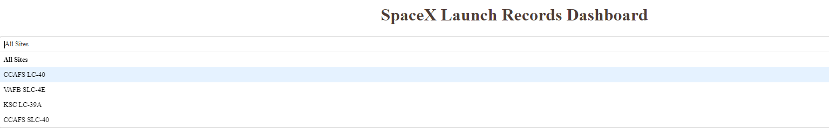

Continue

**TASK 2: Add a callback function to render success-pie-chart based on selected site dropdown**

The general idea of this callback function is to get the selected launch site from site-dropdown and render a pie chart visualizing launch success counts.

Dash callback function is a type of Python function which will be automatically called by Dash whenever receiving an input component updates, such as a click or dropdown selecting event.

If you need to refresh your memory about Plotly Dash callback functions, you may refer to the lab you have learned before:

[**Plotly Dash Lab**](https://cf-courses-data.s3.us.cloud-object-storage.appdomain.cloud/IBMDeveloperSkillsNetwork-DV0101EN-SkillsNetwork/labs/Module%204/4.7_Dash_Interactivity.py)

Let's add a callback function in spacex_dash_app.py including the following application logic:

* Input is set to be the site-dropdown dropdown, i.e., Input(component_id='site-dropdown', component_property='value')
* Output to be the graph with id success-pie-chart, i.e., Output(component_id='success-pie-chart', component_property='figure')
* A If-Else statement to check if ALL sites were selected or just a specific launch site was selected
  + If ALL sites are selected, we will use all rows in the dataframe spacex_df to render and return a pie chart graph to show the total success launches (i.e., the total count of class column)
  + If a specific launch site is selected, you need to filter the dataframe spacex_df first in order to include the only data for the selected site. Then, render and return a pie chart graph to show the success (class=1) count and failed (class=0) count for the selected site.

Here is an example of a callback function:

# Function decorator to specify function input and output

@app.callback(Output(component_id='success-pie-chart', component_property='figure'),

Input(component_id='site-dropdown', component_property='value'))

**def** **get_pie_chart**(entered_site):

filtered_df = spacex_df

**if** entered_site == 'ALL':

fig = px.pie(data, values='class',

names='pie chart names',

title='title')

**return** fig

else:

# return the outcomes piechart for a selected site

The rendered pie chart should look like the following screenshots:

* Pie chart for all sites are selected

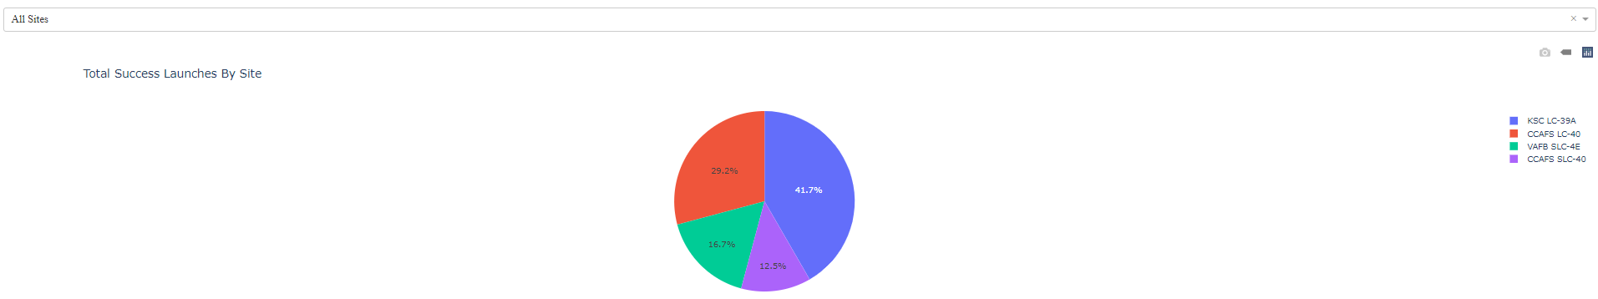

* Pie chart for is selected

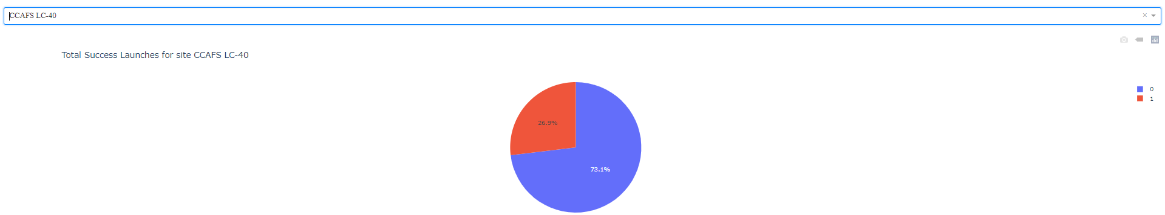

If you need more reference about dash callbacks and plotly pie charts, refer to the Plotly Dash Reference section towards the end of this lab.

**TASK 3: Add a Range Slider to Select Payload**

Next, we want to find if variable payload is correlated to mission outcome. From a dashboard point of view, we want to be able to easily select different payload range and see if we can identify some visual patterns.

Find and complete a commented dcc.RangeSlider(id='payload-slider',...) input with the following attribute:

* id to be payload-slider
* min indicating the slider starting point, we set its value to be 0 (Kg)
* max indicating the slider ending point to, we set its value to be 10000 (Kg)
* step indicating the slider interval on the slider, we set its value to be 1000 (Kg)
* value indicating the current selected range, we could set it to be min_payload and max_payload

Here is an example of RangeSlider:

**dcc**.RangeSlider(id='id',

**min**=0, max=10000, step=1000,

**marks**={0: '0',

**100**: '100'},

**value**=[min_value, max_value])

You completed payload range slider should be similar the following screenshot: 

If you need more reference about range slider, refer to the Plotly Dash Reference towards the end of this lab.

**TASK 4: Add a callback function to render the success-payload-scatter-chart scatter plot**

Next, we want to plot a scatter plot with the x axis to be the payload and the y axis to be the launch outcome (i.e., class column). As such, we can visually observe how payload may be correlated with mission outcomes for selected site(s).

In addition, we want to color-label the Booster version on each scatter point so that we may observe mission outcomes with different boosters.

Now, let's add a call function including the following application logic:

* Input to be [Input(component_id='site-dropdown', component_property='value'), Input(component_id="payload-slider", component_property="value")] Note that we have two input components, one to receive selected launch site and another to receive selected payload range
* Output to be Output(component_id='success-payload-scatter-chart', component_property='figure')
* A If-Else statement to check if ALL sites were selected or just a specific launch site was selected
  + If ALL sites are selected, render a scatter plot to display all values for variable Payload Mass (kg) and variable class. In addition, the point color needs to be set to the booster version i.e., color="Booster Version Category"
  + If a specific launch site is selected, you need to filter the spacex_df first, and render a scatter chart to show values Payload Mass (kg) and class for the selected site, and color-label the point using Boosster Version Category likewise.

If you need more reference about dash callbacks and plotly scatter plots, refer to the Plotly Dash Reference towards the end of this lab.

**Finding Insights Visually**

Now with the dashboard completed, you should be able to use it to analyze SpaceX launch data, and answer the following questions:

1. Which site has the largest successful launches?
2. Which site has the highest launch success rate?
3. Which payload range(s) has the highest launch success rate?
4. Which payload range(s) has the lowest launch success rate?
5. Which F9 Booster version (v1.0, v1.1, FT, B4, B5, etc.) has the highest

launch success rate?

**Plotly Dash Reference**

**Dropdown (input) component**

Refer [**here**](https://dash.plotly.com/dash-core-components/dropdown?utm_medium=Exinfluencer&utm_source=Exinfluencer&utm_content=000026UJ&utm_term=10006555&utm_id=NA-SkillsNetwork-Channel-SkillsNetworkCoursesIBMDS0321ENSkillsNetwork26802033-2022-01-01) for more details about dcc.Dropdown()

**Range slider (input) component**

Refer [**here**](https://dash.plotly.com/dash-core-components/rangeslider?utm_medium=Exinfluencer&utm_source=Exinfluencer&utm_content=000026UJ&utm_term=10006555&utm_id=NA-SkillsNetwork-Channel-SkillsNetworkCoursesIBMDS0321ENSkillsNetwork26802033-2022-01-01) for more details about dcc.RangeSlider()

**Pie chart (output) component**

Refer [**here**](https://plotly.com/python/pie-charts/?utm_medium=Exinfluencer&utm_source=Exinfluencer&utm_content=000026UJ&utm_term=10006555&utm_id=NA-SkillsNetwork-Channel-SkillsNetworkCoursesIBMDS0321ENSkillsNetwork26802033-2022-01-01) for more details about plotly pie charts

**Scatter chart (output) component**

Refer [**here**](https://plotly.com/python/line-and-scatter/?utm_medium=Exinfluencer&utm_source=Exinfluencer&utm_content=000026UJ&utm_term=10006555&utm_id=NA-SkillsNetwork-Channel-SkillsNetworkCoursesIBMDS0321ENSkillsNetwork26802033-2022-01-01) for more details about plotly scatter charts

**Author**

[**Yan Luo**](https://www.linkedin.com/in/yan-luo-96288783/?utm_medium=Exinfluencer&utm_source=Exinfluencer&utm_content=000026UJ&utm_term=10006555&utm_id=NA-SkillsNetwork-Channel-SkillsNetworkCoursesIBMDS0321ENSkillsNetwork26802033-2022-01-01)

**Other contributor(s)**

Joseph Santarcangelo

**Changelog**

| **Date** | **Version** | **Changed by** | **Change Description** |
| --- | --- | --- | --- |
| 29-08-2022 | 1.2 | Lakshmi Holla | Updated screenshot. |
| 03-09-2021 | 1.1 | Lakshmi Holla | Added a note. |
| 06-01-2021 | 1.0 | Yan | Initial version created |

**© IBM Corporation 2021. All rights reserved.**